##### **Step 1 : Get the IIS cookbook**

Now let's practice uploading a cookbook to the Chef server.

knife cookbook site download learn_chef_iis



##### **Step 2 : Get the IIS cookbook**

Let us untar the cookbook to cookbooks folder

tar -zxvf learn_chef_iis-0.2.1.tar.gz -C cookbooks

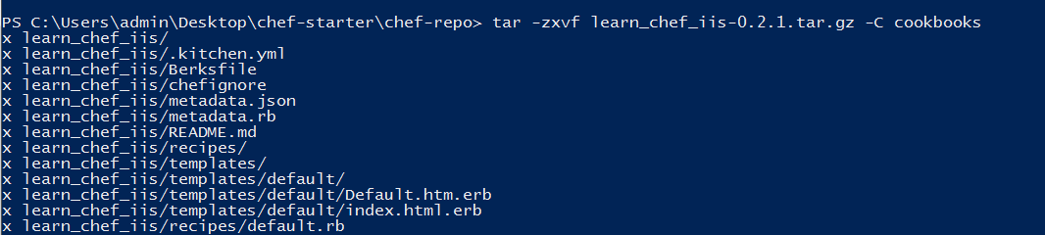

## **Step 3 :Upload your cookbook to the Chef server**

Now upload the Learn Chef IIS cookbook to your Chef server. Run this command from anywhere under your ~/learn-chefdirectory.

knife cookbook upload learn_chef_iis



## **Step 4 : Apply your IIS cookbook run list**

knife bootstrap -N windows winrm 54.163.96.253 -m -x Administrator -P Ch4ng3m3 --run-list learn_chef_iis

Through GUI ( Optional )

Select your node and Go to edit run list

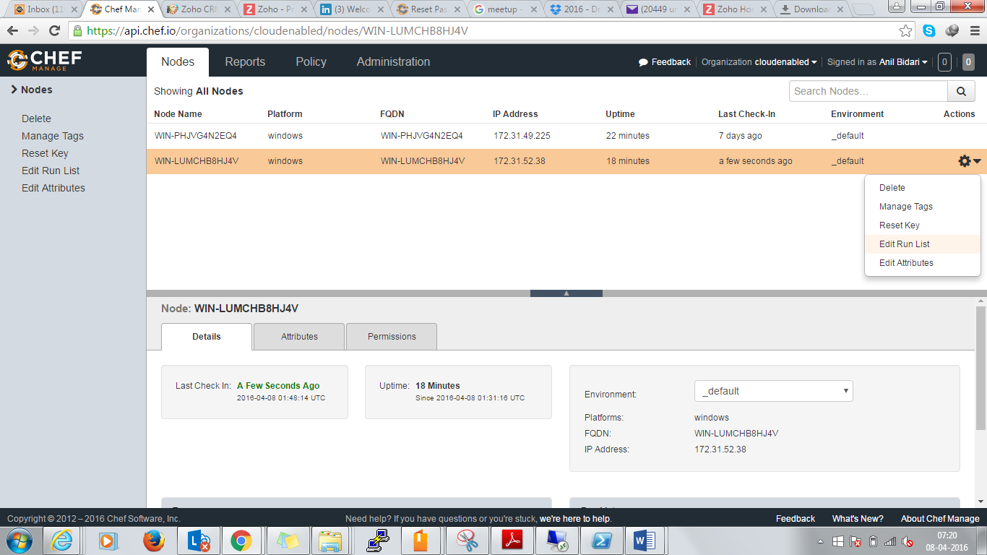

Add learn_chef_iis in run list and save

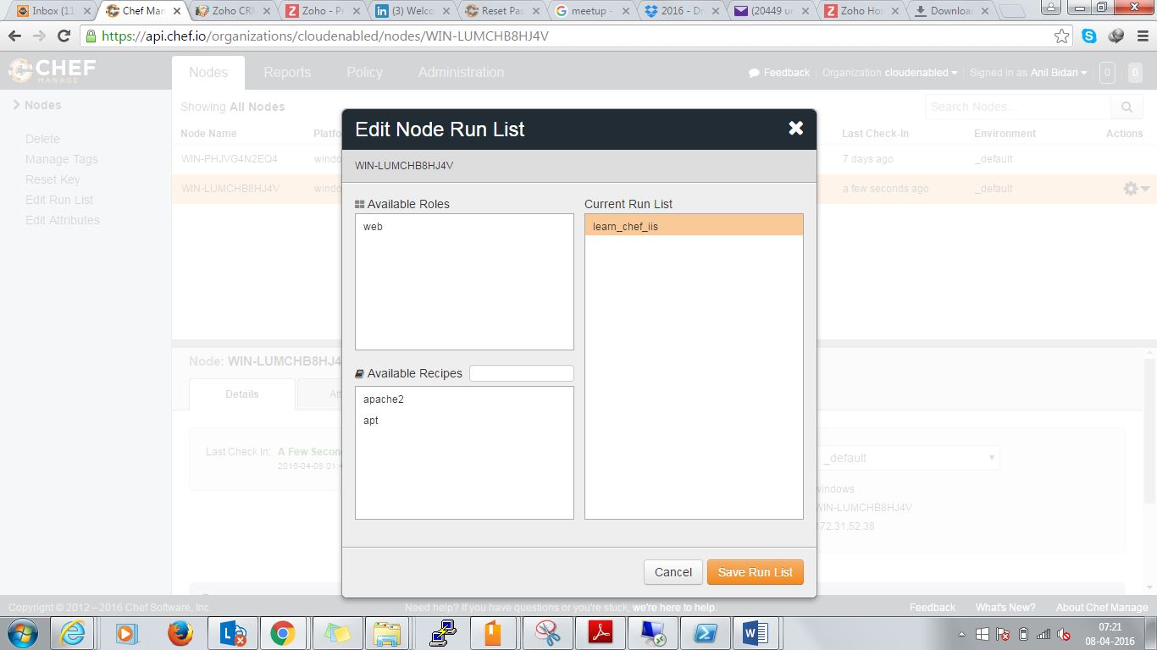

RDP to your machine ,open owershell as Administrator and run below command

chef-client

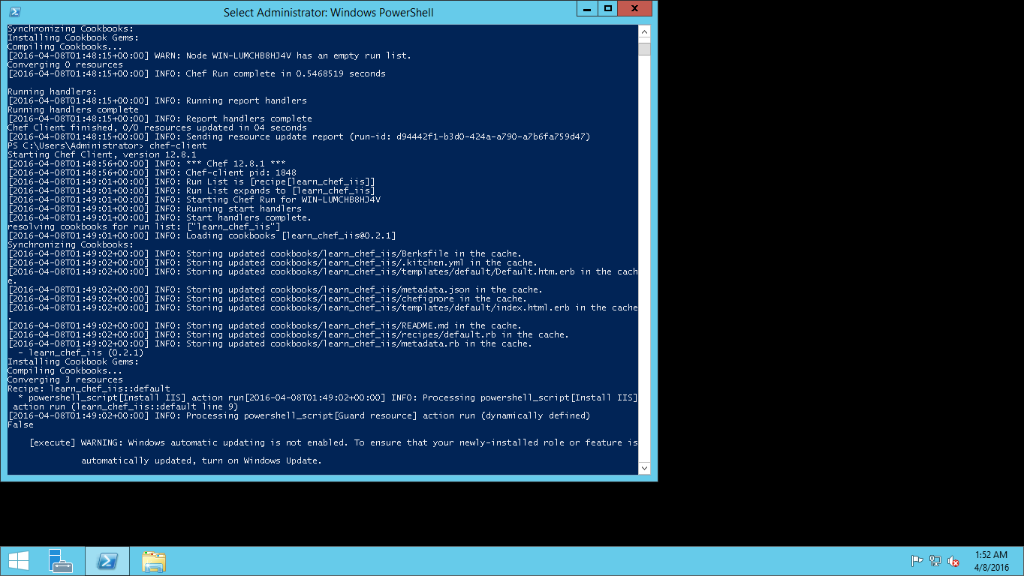

Goto ec dashboard and copy your public IP

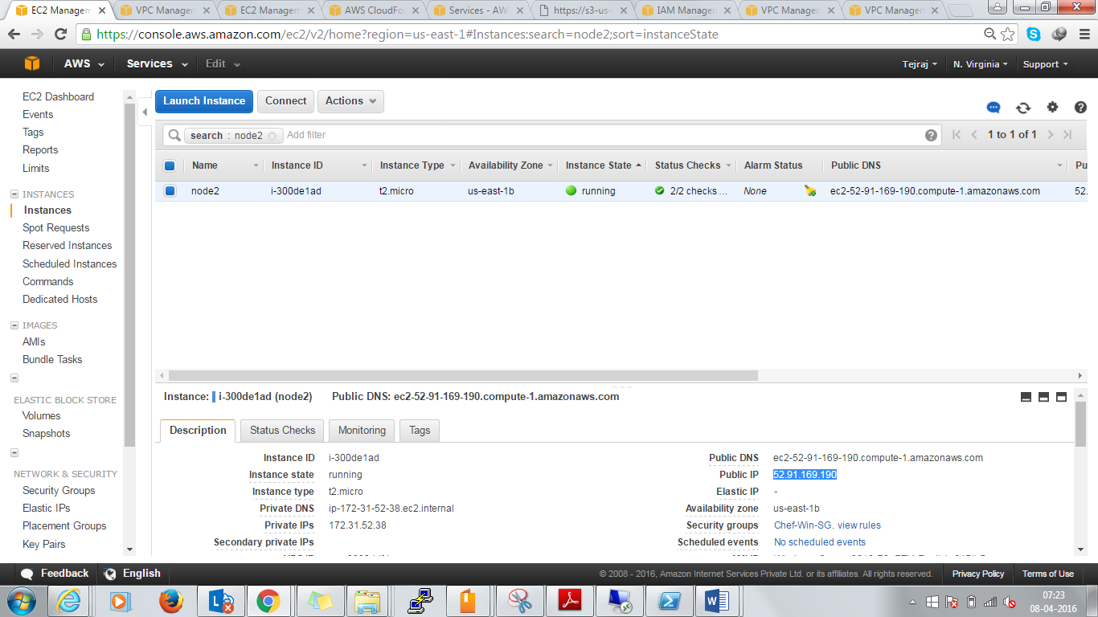

Open browser and validate you can get default web page

